Participation and Coproduction Evidence Log
This document is for collecting information about participation activity in ……………
It is to evidence partnership working between young people, parents/carers, the local authority and clinical commissioning group. Evidence will be shared via the local offer, governance boards and maybe used for the joint local area inspection.

Summary of work. Please give a short overview of the work completed. This is the important information that lets others know what happened.

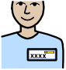
Contact details of lead person/s

Name Email Phone

What will you work together on?
What will you ask? And when in the process?
Happy?

Who will see the information and what will they do with it?

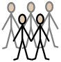

People involved (numbers, where they were from, age range, additional needs etc.)

What parents/carers said?

What children and young people said?

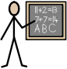
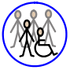

What practitioners said?

What has changed? What decisions have been made?

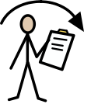
Have you fed back?
No
Yes

How have you fed back? When?

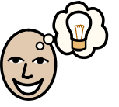

What important things have you learnt from this experience?

Please feel free to send pictures, videos, results and any evidence with this information. All evidence forms are accepted.

